Responsibly Produced Peat in process to grant certificate
Date of publication August 3, 2022

Responsibly Produced Peat intends to grant the RPP-certificate to the company named in this document. This intended decision is based on the fact that the company meets the requirements of the RPP certification scheme version 3.0. The fulfilment of the criteria is checked by an independent qualified inspector, including inspection at location.
During a period of 6 weeks, from August 4 until September 15 , 2022 Responsibly Produced Peat offers parties concerned the opportunity to provide comment on the proposed decision. Questions and comments can be sent to info@responsiblyproducedpeat.org. Without further objections, after this comment period, the certificate will be granted to the company for the location in concern.
Company name | AS Tootsi Turvas  Papiniidu 5/1, 80010 Pärnu
Extraction site | Name site:  Kasesoo turbatootmisala
GPS coordinate entrance peatbog:
Latitude : N 59° 8'5.455''
Longitude: E 27°38'59.865''
Total licensed area:
205,71ha

License information:
License number KMIN-080
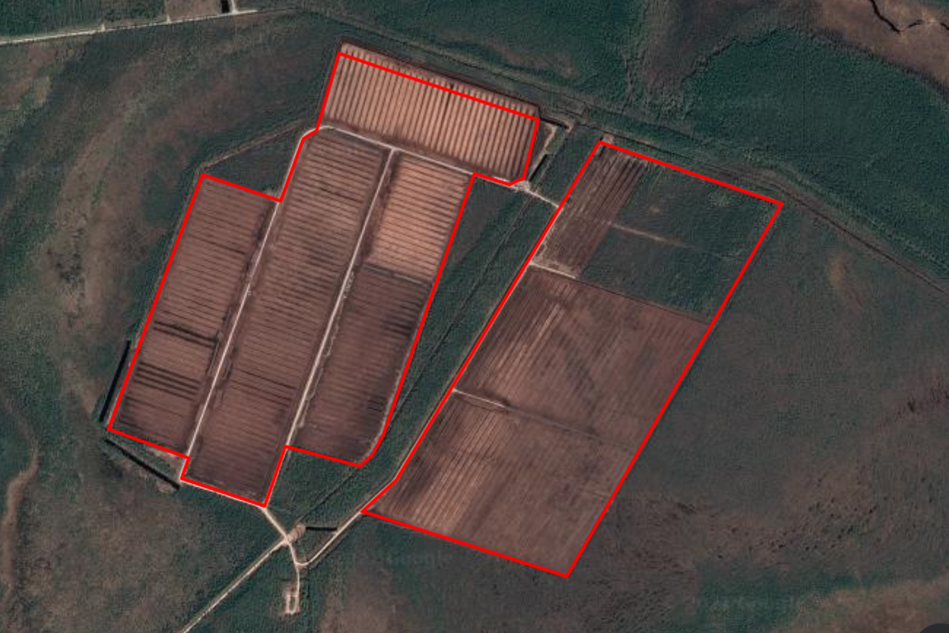
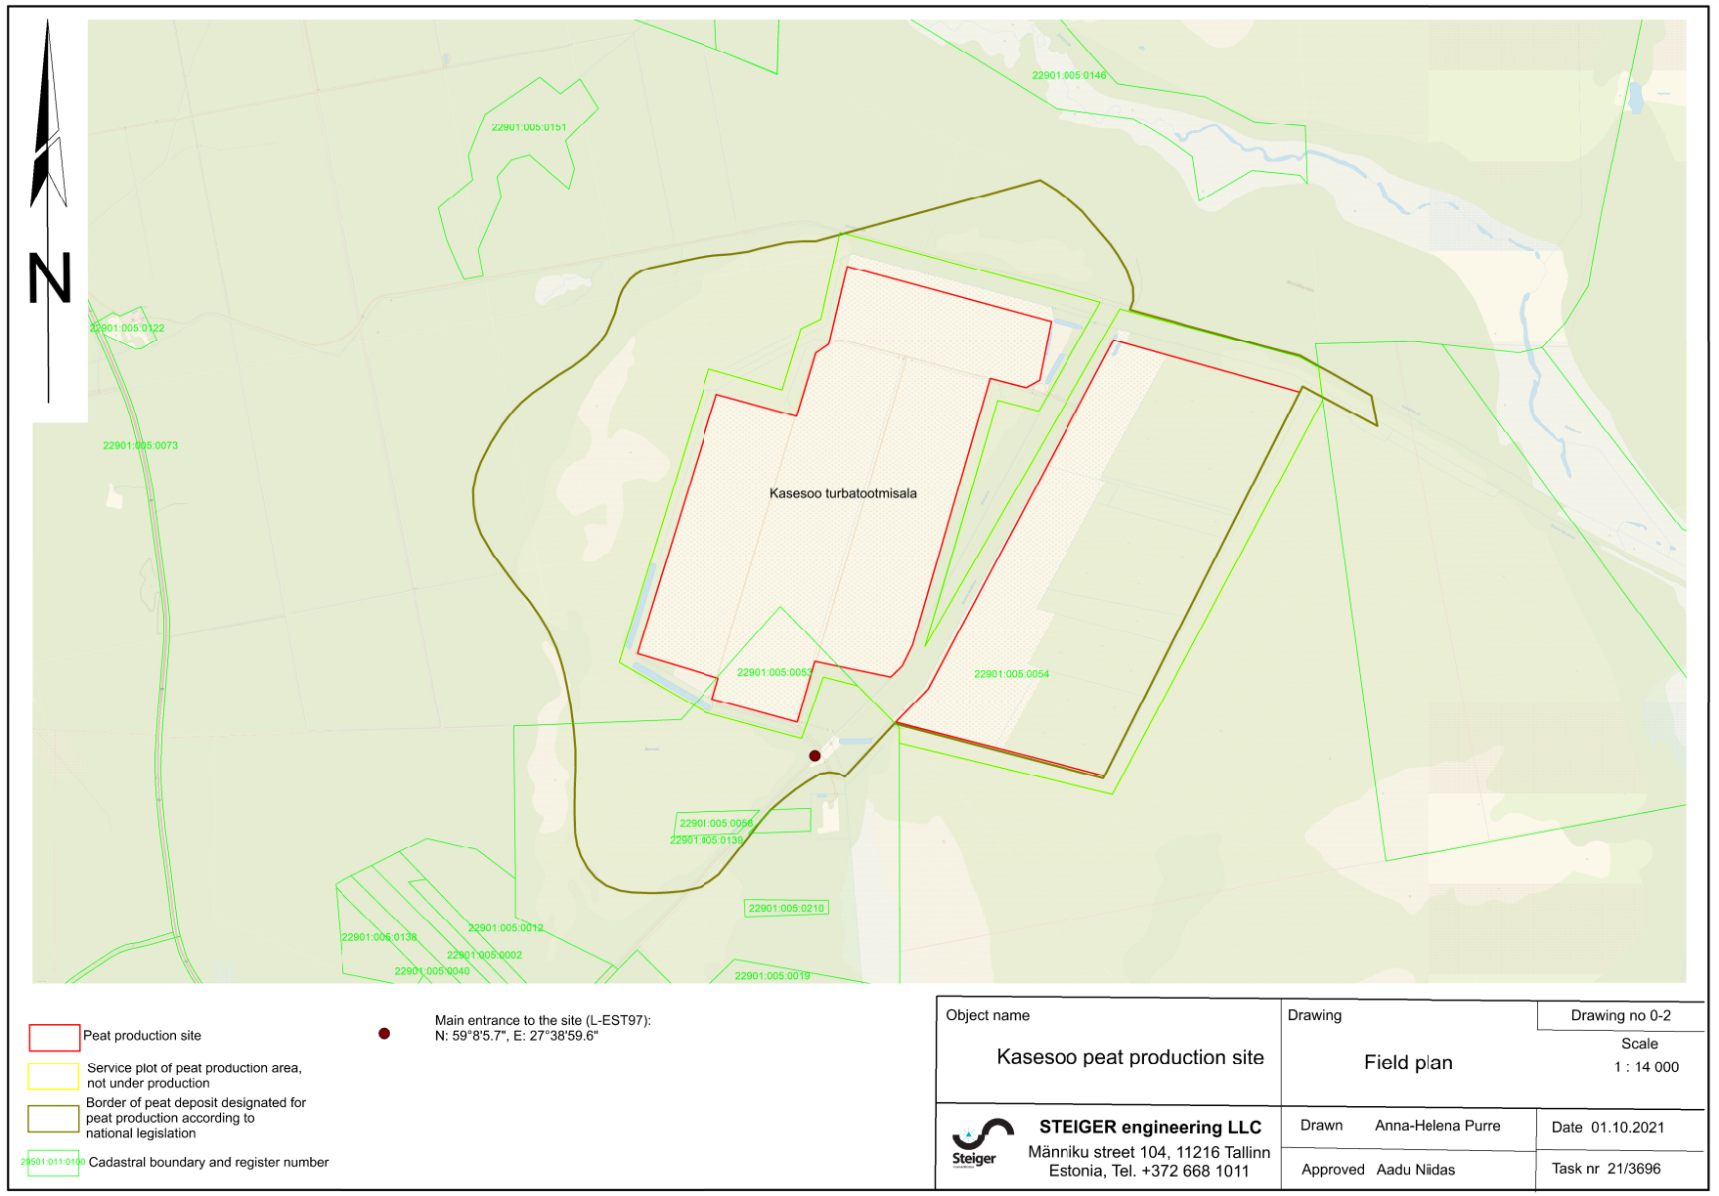
- According to the inspection, monitoring and mitigation plans are sufficiently implemented.

- In addition to the provided preliminary after-use plan, an overview of the current state of the after-use of sites where the reclamation process has started or will be started in next 5 years will be provided. Consultations with the Environmental Board and feedback from other stakeholders will be part of the process.

